**VEHICLES SECURITY RECORD SYSTEM (VSRS)**

Number Plate Recognition

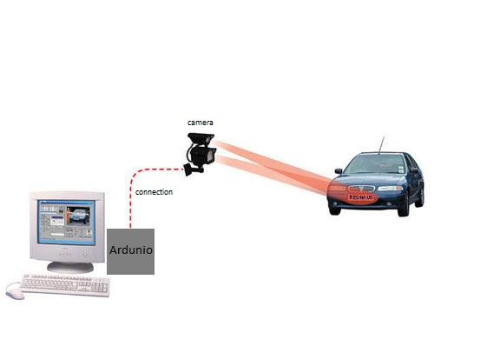

**Above picture is the overview design of VEHICLE SECURITY RECORD SYSTEM**

**(Number plate recognition)**

**Development Stages**

**System concept:**

* **Who is the application for?** A number of Institutes provide this system. Only a Institute where more number of vehicles enters into campus could possibly justify the cost and effort of building this system.

A Institute would be competing for record the data of vehicle for security purpose.

* **What problems will it solve?** This system is intended to serve the Institute security. This system increases automation and reduces manual handling of routine paperwork. It is easy to use and its convenient.
* **Where will it be used?** This system is essential to Institute or Organisation where more number of vehicles enter into there campus.
* **When is it needed?** From a security perspective, it is desirable to minimize the paper work of recording vehicle data and for security purpose.
* **Why is it needed?** It helps to store the vehicle data whithout help of any security person. And its helpful to secure the data safely in system.
* **How will it work?** We will adopt a one tier architecture that include the interface, middleware and back-end data, in one place.

**Analysis:**

* **Requirements**

1. Arduino board
2. OV7670 Camera module
3. 10k resisters
4. 4.7k resisters
5. Bread Board
6. Arduino wires
7. Python program (Tesseract Module)
8. System to store the data

* **Classes**

1. Vehicle
2. Camera
3. Ardunio
4. System
5. Data base

**System design:**

* It consist of One Tier architecture design

DATA BASE

SYSTEM

ARDUNIO

VEHICLE

Diagram: One Tier Architecture of VSRS

**Class model:**

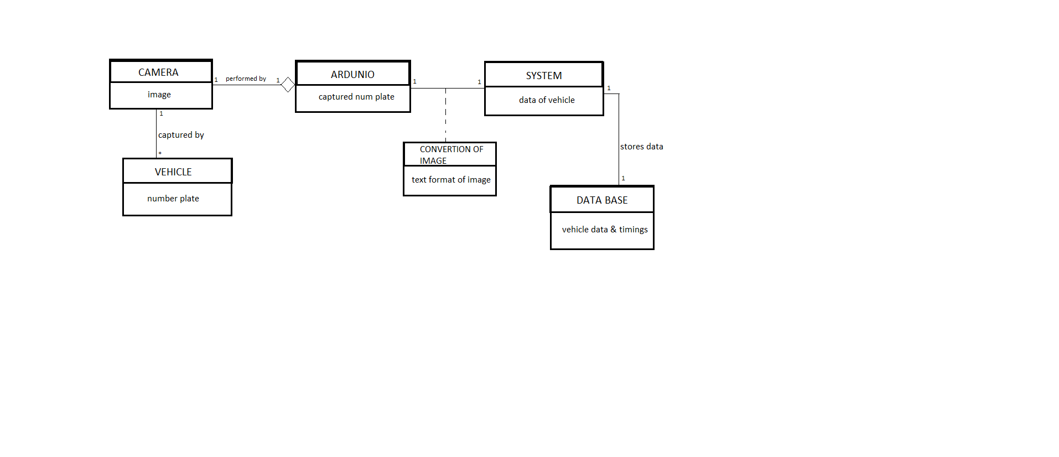

* Here the any number of Vehicle class which enters has a number plate
* The camera class which consist of image of that number plate
* Ardunio class which performs the camera to capture
* Now convertion of image which is association class which converts image into text by the help of Python programing Language
* Later the system class which collects the data after convertion of image
* Database class which stores the image.

**State model:**

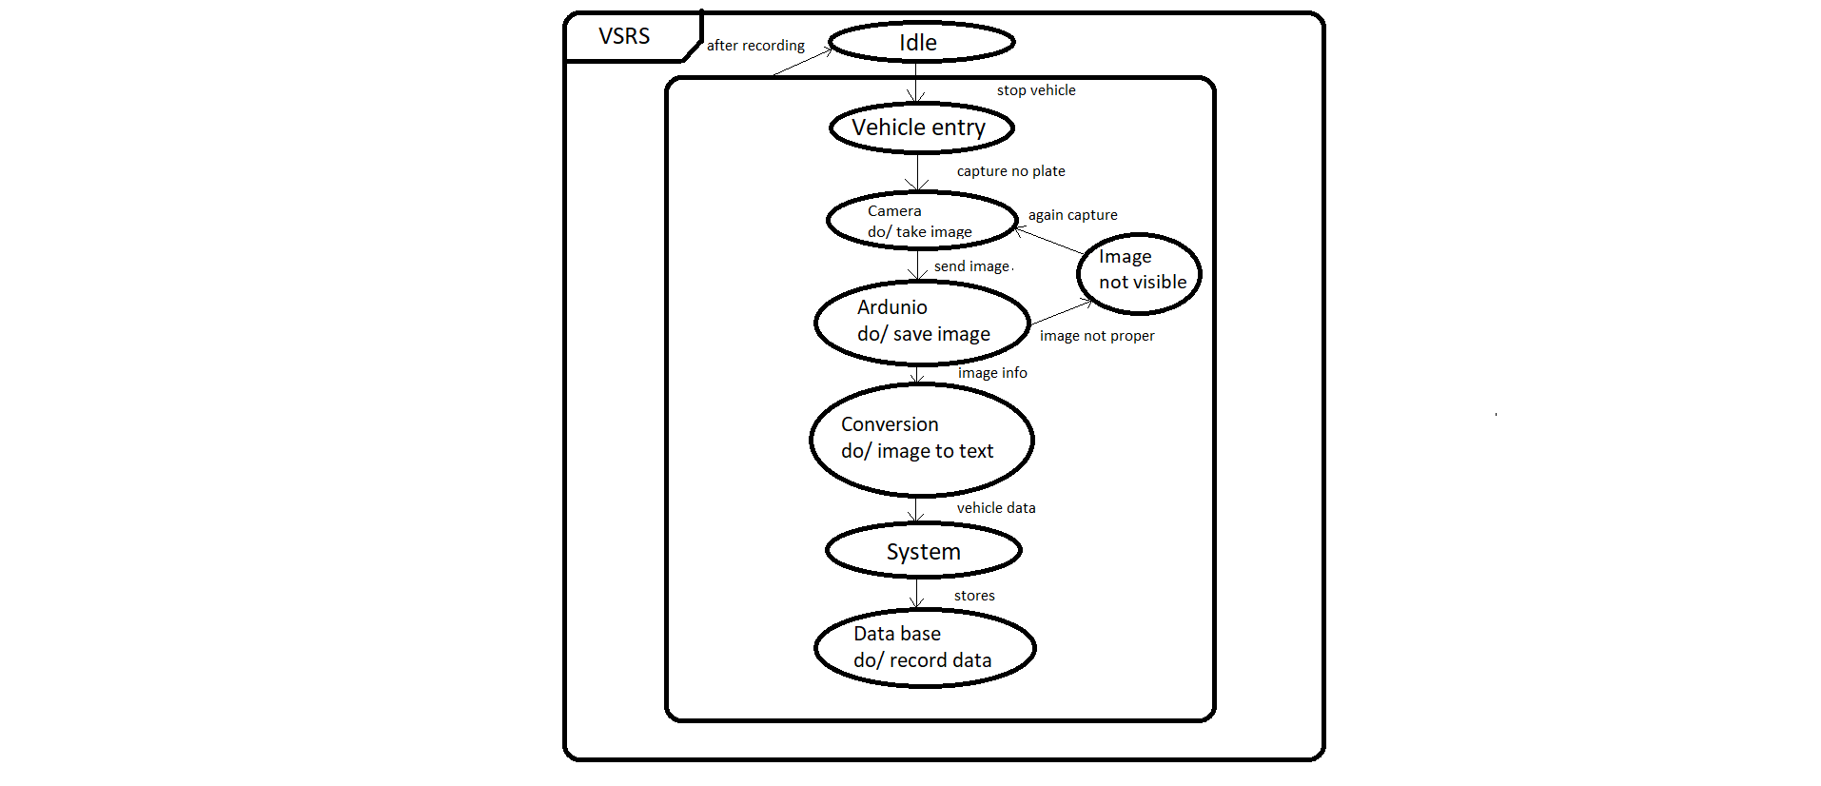

* Nested states for VEHICLE SECURITY RECORD SYSTEM (plate recognition)
* It shows communality of each state and behavior

**Use case model:**

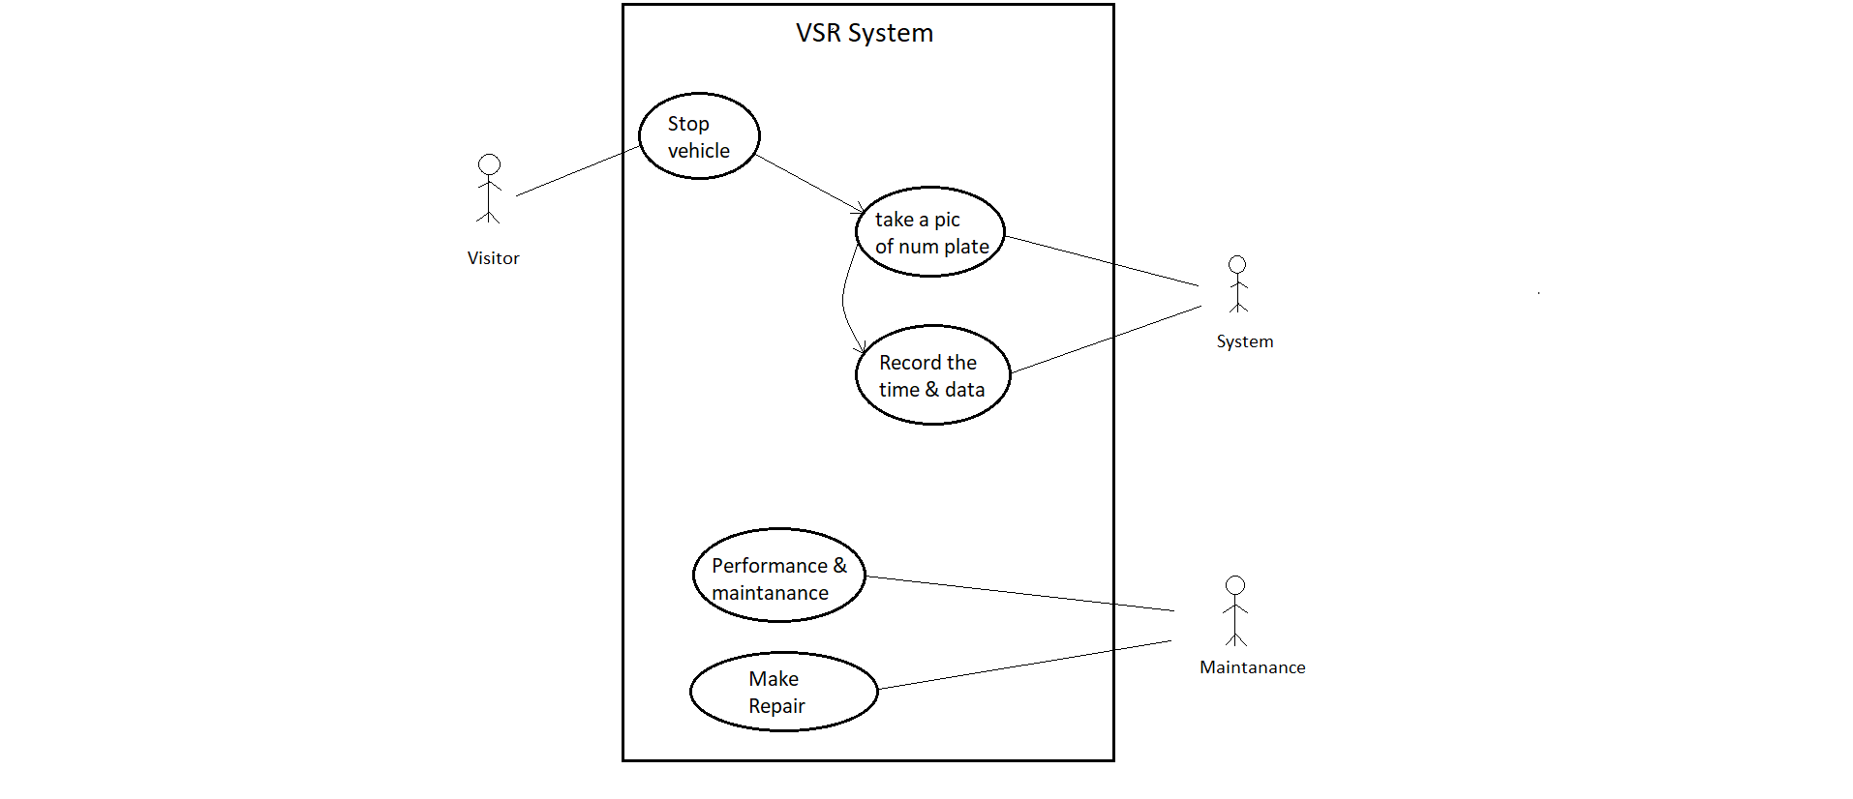

* It is a Use case diagram for Vehicle Security Record System
* It involves set of usecase and actors to perform the system
* A “stick man” icon denotes an actor, with the name being placed below
* Solid lines connect use cases to participating actors

**Sequence model:**

* **Scenarios:**
* Visitor Vehicle entry to college.
* Visitor should stop the vehicle.
* System camera will capture number plate of vehicle.
* With the help of Ardunio takes image.
* System using Python converts image into form of canny edge image format.
* Python will convert that edge image to text format with the help of Tesseract
* The data text will record into database with entering time.
* Vehicle will goes inside the college.
* **Sequence diagram:**

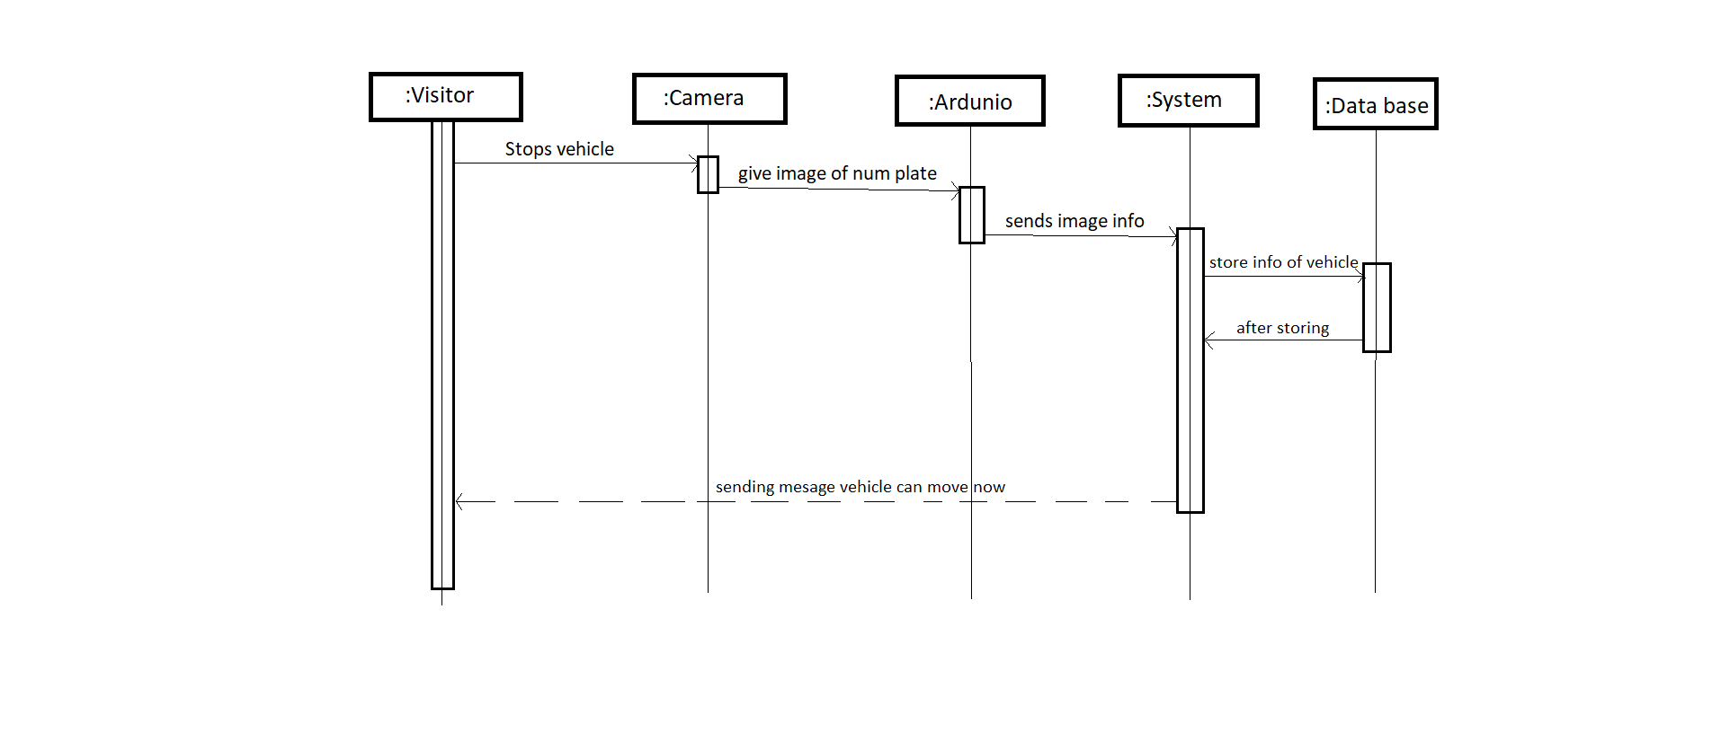

* In this diagram it is containing an independent objects
* Here not all objects are constantly active
* Some of the objects are Passive and it is not activated until it has been called
* The UML shows the period of time for an object’s execution as a thin rectangle
* Activity diagram: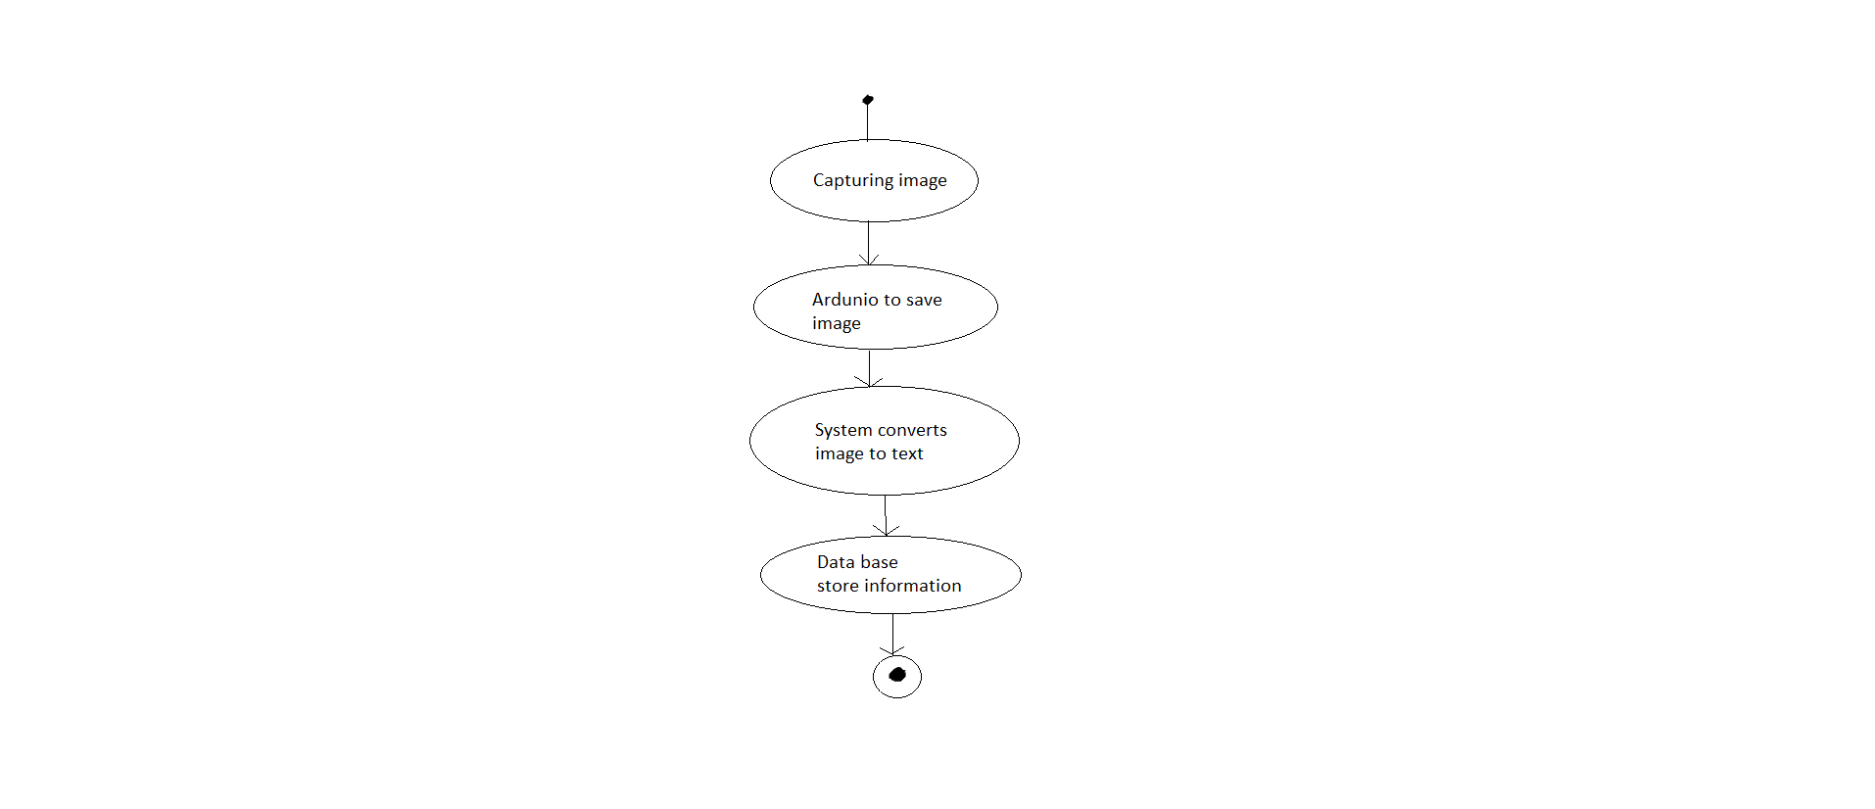

Here it shows the fine control of an event in the VEHICLE SECURITY RECORD SYSTEM (plate recognition)

Here you can see how system will works:

<https://www.youtube.com/watch?v=VWGFr7g0qxU>